EXP-6

6. Implement and perform streaming data analysis using flume for data capture,pyspark/hive for data analysis of Twitter data, chat data, and weblog analysis

Aim
1.To implement and perform streaming data analysis using:
- Apache Flume for data capture
- PySpark for real-time analytics
- Apache Hive for querying and reporting
Data Sources:
- Twitter Data
- Chat Data
- Web Log Data

2.Flow chart
Twitter API / Chat Messages / Web Logs
↓
Apache Flume
↓
HDFS
↓
PySpark Streaming
↓
Hive
↓
Analytics Results

3. Software Requirements
Software | Purpose
Hadoop HDFS | Distributed Storage
Apache Flume | Streaming Data Capture
Apache Spark | Stream Processing
PySpark | Analytics
Hive | Data Warehouse
Python | Programming
Linux | Execution Environment

2. Twitter Data Capture using Flume

Twitter Configuration File
File: twitter.conf
agent.sources = twitter-source
agent.channels = memory-channel
agent.sinks = hdfs-sink

agent.sources.twitter-source.type = org.apache.flume.source.twitter.TwitterSource

agent.sources.twitter-source.consumerKey = XXXXX
agent.sources.twitter-source.consumerSecret = XXXXX
agent.sources.twitter-source.accessToken = XXXXX
agent.sources.twitter-source.accessTokenSecret = XXXXX

agent.sources.twitter-source.keywords = Spark,Hadoop,AI

agent.channels.memory-channel.type = memory

agent.sinks.hdfs-sink.type = hdfs
agent.sinks.hdfs-sink.hdfs.path = hdfs://localhost:9000/twitter/

agent.sources.twitter-source.channels = memory-channel
agent.sinks.hdfs-sink.channel = memory-channel
Start Twitter Streaming
flume-ng agent \
--conf conf \
--conf-file twitter.conf \
--name agent

3. Twitter Data Analysis using PySpark

PySpark Program
from pyspark.sql import SparkSession
from pyspark.sql.functions import *

spark = SparkSession.builder \
.appName("TwitterAnalysis") \
.getOrCreate()

twitter_df = spark.read.json(
"hdfs://localhost:9000/twitter/"
)

positive_words = ["good","excellent","happy"]

def sentiment(text):
if text:
for word in positive_words:
if word in text.lower():
return "Positive"
return "Negative"

from pyspark.sql.types import StringType
from pyspark.sql.functions import udf

sentiment_udf = udf(sentiment, StringType())

result = twitter_df.withColumn(
"Sentiment",
sentiment_udf(col("text"))
)
result.show()

Twitter Input Table
Tweet ID | Tweet Text
101 | Spark is excellent
102 | Big data analytics is good
103 | Server issue today
104 | AI conference update

Twitter Output Result Table
Tweet Text | Sentiment
Spark is excellent | Positive
Big data analytics is good | Positive
Server issue today | Negative
AI conference update | Negative
- Chat Data Streaming using Flume

Chat Configuration
File: chat.conf
agent.sources = netcat-source
agent.channels = memory-channel
agent.sinks = hdfs-sink

agent.sources.netcat-source.type = netcat
agent.sources.netcat-source.bind = localhost
agent.sources.netcat-source.port = 44444

agent.channels.memory-channel.type = memory

agent.sinks.hdfs-sink.type = hdfs
agent.sinks.hdfs-sink.hdfs.path = hdfs://localhost:9000/chat/

agent.sources.netcat-source.channels = memory-channel
agent.sinks.hdfs-sink.channel = memory-channel

Start Chat Streaming
flume-ng agent \
--conf conf \
--conf-file chat.conf \
--name agent
Send Chat Messages
telnet localhost 44444

Chat Input Table
Message ID | Chat Message
1 | hello spark
2 | spark streaming
3 | big data analytics
4 | hello hadoop

Chat Data Analysis using PySpark

Word Count Program
chat_df = spark.read.text(
"hdfs://localhost:9000/chat/"
)

words = chat_df.select(
explode(split(col("value")," ")).alias("word")
)

wordcount = words.groupBy("word").count()

wordcount.show()

Chat Output Result Table
Word | Count
hello | 2
spark | 2
streaming | 1
analytics | 1
hadoop | 1
- Web Log Streaming using Flume

Web Log Configuration
File: weblog.conf
agent.sources = exec-source
agent.channels = memory-channel
agent.sinks = hdfs-sink

agent.sources.exec-source.type = exec
agent.sources.exec-source.command = tail -F /var/log/apache2/access.log

agent.channels.memory-channel.type = memory

agent.sinks.hdfs-sink.type = hdfs
agent.sinks.hdfs-sink.hdfs.path = hdfs://localhost:9000/weblogs/

agent.sources.exec-source.channels = memory-channel
agent.sinks.hdfs-sink.channel = memory-channel

Start Web Log Streaming

flume-ng agent \
--conf conf \
--conf-file weblog.conf \
--name agent

Web Log Input Table
IP Address | URL | Status
192.168.1.1 | /home | 200
192.168.1.2 | /login | 404
192.168.1.1 | /products | 200
Web Log Analysis using PySpark
IP Address Analysis
log_df = spark.read.text(
"hdfs://localhost:9000/weblogs/"
)

ip_df = log_df.select(
split(col("value")," ").getItem(0).alias("IP")
)

ip_df.groupBy("IP").count().show()

Web Log Output Result Table
IP Address | Number of Hits

192.168.1.1 | 2

192.168.1.2 | 1
HTTP Status Analysis

status_df = log_df.select(
split(col("value")," ").getItem(8).alias("Status")
)

status_df.groupBy("Status").count().show()

HTTP Status Result Table
Status Code | Count
200 | 2
404 | 1

URL Access Analysis

Code
url_df = log_df.select(
split(col("value")," ").getItem(6).alias("URL")
)

url_df.groupBy("URL").count().show()

URL Access Result Table

URL | Visits

/home | 1

/products | 1

/login | 1

6. Hive Integration

Create Hive Tables
Twitter Table
CREATE EXTERNAL TABLE twitter_data(
id STRING,
text STRING
)
LOCATION '/twitter/';

Chat Table

CREATE EXTERNAL TABLE chat_data(
message STRING
)
LOCATION '/chat/';

Web Log Table
CREATE EXTERNAL TABLE weblog_data(
logs STRING
)
LOCATION '/weblogs/';

7. Hive Query Results

Twitter Query

SELECT * FROM twitter_data;

Hive Twitter Result Table
Tweet Text

Spark is excellent

Big data analytics is good

Server issue today

Chat Query
SELECT * FROM chat_data;
Hive Chat Result Table

Chat Messages

hello spark

spark streaming

big data analytics

8. Structured Streaming using PySpark
Real-Time Streaming Program

stream_df = spark.readStream.text(
"hdfs://localhost:9000/chat/"
)

query = stream_df.writeStream \
.outputMode("append") \
.format("console") \
.start()

query.awaitTermination()

Streaming Output Result Table
Batch | Streaming Messages
0 | hello spark
0 | spark streaming
0 | big data analytics

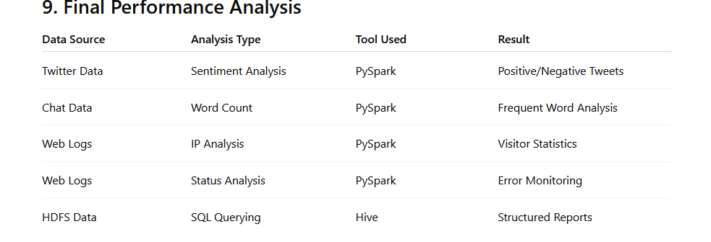

10. Applications
- Social media analytics
- Smart city monitoring
- IoT data analytics
- Fraud detection
- Cybersecurity systems
- Customer behavior analysis
- Network traffic monitoring

11. Advantages
- Real-time processing
- High scalability
- Distributed storage
- Fast analytics
- Fault tolerance
- Hadoop ecosystem integration

12. Conclusion
The streaming analytics system successfully captures and analyzes Twitter data, chat messages, and weblog data using Apache Flume, PySpark, and Hive.
The implementation demonstrates:
- Real-time data capture using Flume
- Distributed storage using HDFS
- Data analytics using PySpark
- SQL querying using Hive
- Efficient processing of streaming big data with meaningful analytical results

